**1.Bug Report / Feature Request: Dynamic Role and Position Based on Office Selection**

There are two related issues regarding how the **Select Position** and **Select Role** dropdowns behave based on the selected **Office**:

**1. If the selected office is "GSO":**

* The **Select Position** field should be **disabled** or **cleared**, since **GSO users do not need to select a client position** like Faculty or Staff.
* The **Select Role** should remain user-defined (Admin, Head, Staff, etc.).

**2. If the selected office is NOT "GSO":**

* The **Select Position** dropdown should remain active.
* The **Select Role** should **automatically be set to "Requester"**, since clients (non-GSO) should only have that role.

**Expected Behavior Summary:**

| **Condition** | **Select Position** | **Select Role** |
| --- | --- | --- |
| Office = GSO | Disabled/cleared | User selects |
| Office ≠ GSO | Active | Auto-set to "Requester" |

**2.Bug Report: Incorrect User Details Displayed During Review**

**Description:**   
When a head user attempts to review individual account requests, the system displays the details of the **most recent requester** regardless of which user is selected. For example, if Brenda is the last to request, her information appears when reviewing Jerome or Rald.

**Steps to Reproduce:**

1. Navigate to the **Admin > User Requests** page.
2. Observe multiple pending user requests (e.g., Brenda, Jerome, Rald).
3. Click the **Review** button beside **Jerome** or **Rald**.
4. Notice that the details shown are for **Brenda** (the last requester), not the selected user.

**Expected Behavior:**

Each time the **Review** button is clicked, the system should display the **correct information** corresponding to the selected user — including full name, email, role, and registration date.

**3.Bug Report: Failed to Update Status on Approve/Disapprove**

**Description:**  
As an **admin**, I am responsible for approving or disapproving user account requests. However, when I attempt to **approve** or **disapprove** a request, the system shows an error message:  
**"Failed to update status"**, even though I expect the status to change accordingly.

**Steps to Reproduce:**

1. Go to the **Admin > User Requests** page.
2. Click **Review** beside any pending user.
3. In the review panel, click **Approve** or **Disapprove**.
4. Observe the system response.
5. A message saying **"Failed to update status"** appears, and the user's status does not change.

**Expected Behavior:**

Upon clicking **Approve** or **Disapprove**, the system should:

* Successfully update the user's status in the database.
* Reflect the new status (approved/disapproved) in the UI.
* Optionally, show a success message like **"Status updated successfully"**.

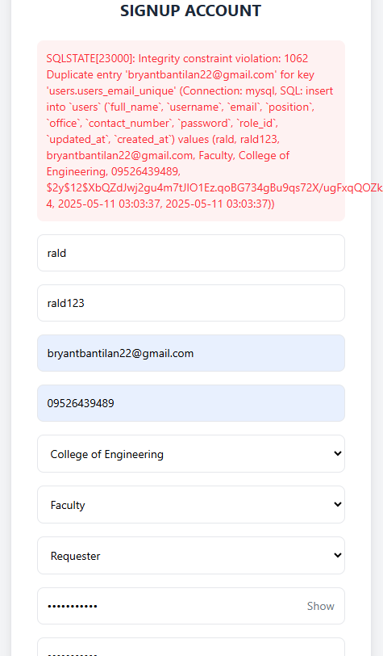4. when I create account when the same gmail that exist this error pop up

5.As a user when I request this error pop up when I submit my request

6. as a admin this error pop up when I submit my request

SQLSTATE[23000]: Integrity constraint violation: 1452 Cannot add or update a child row: a foreign key constraint fails (`manageit_db`.`maintenance_requests`, CONSTRAINT `maintenance_requests_maintenance_type_id_foreign` FOREIGN KEY (`maintenance_type_id`) REFERENCES `maintenance_types` (`id`) ON DELETE CASCADE) (Connection: mysql, SQL: insert into `maintenance_requests` (`date_requested`, `details`, `requesting_personnel`, `position`, `requesting_office`, `contact_number`, `maintenance_type_id`, `updated_at`, `created_at`) values (2025-05-11, xdtydh, Admin User, Administrator, GSO, 09123456789, 1, 2025-05-11 13:27:36, 2025-05-11 13:27:36))A screenshot of a computer
\

1. as a staff when I request I have the same error with user,admin, and head

